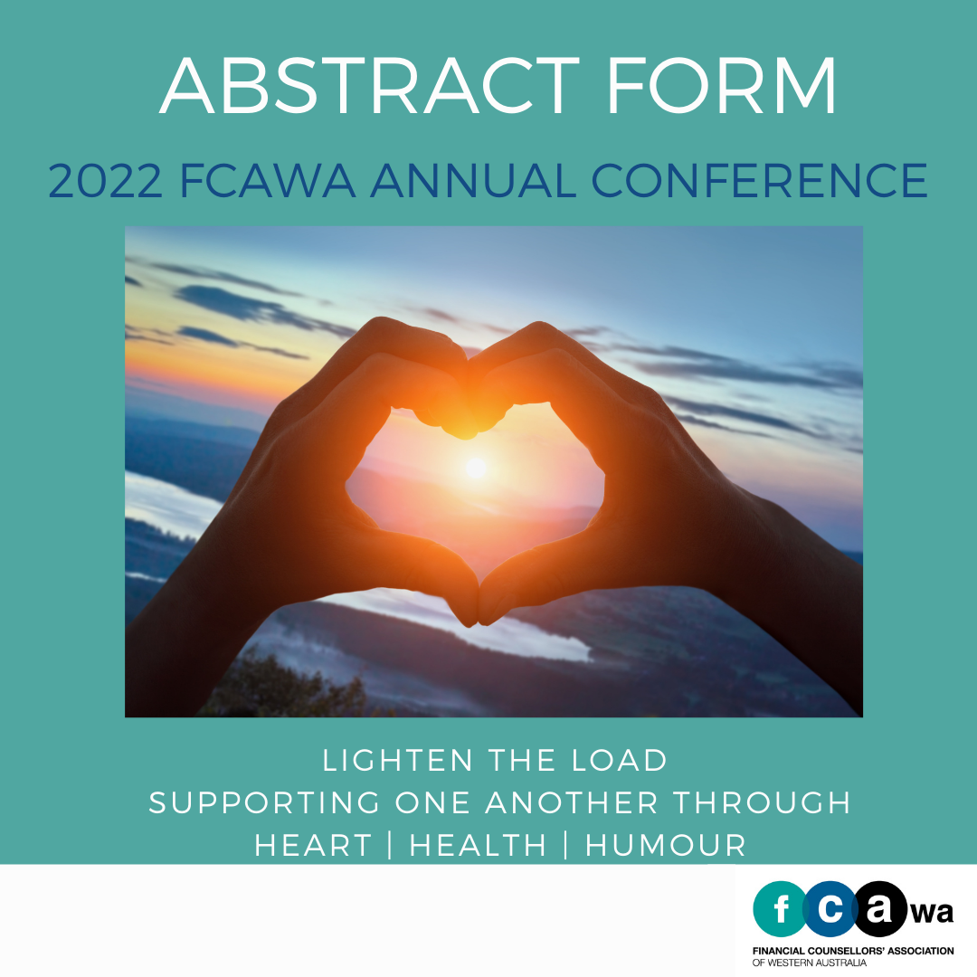
Aloft Hotel | 27 Rowe Ave, Rivervale

Title of Abstract:

Presenter/s:

Organisation:

Position Title:

Contact Details: Email

Phone

Preferred Format
(eg plenary/breakout):

Length of Presentation:

_________________________________________________________________________

Abstract (250 Word Maximum)

Short Biography of Presenter/s – 150 Words Each (Please also attach a photo)

